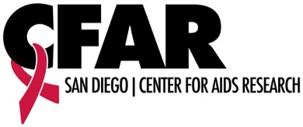
SD CFAR 2019 Rising Star
Emerging Investigator Award
Abstract Submission

Email your best abstract in 2019 or use the format below for a new abstract to cfar@ucsd.edu by 5:00 p.m. on Friday, November 15, 2019. The next SD CFAR Rising Star Investigator will be announced on Monday, December 9. The winner will receive a $200 voucher to be used at the UC San Diego Bookstore.* Give us your best! Reviewers are waiting!

Please provide the following information. If submitting an existing abstract, include this page with a PDF of your existing abstract. If submitting a new abstract, follow the format below and submit with this page.
Abstract Title
Purpose of abstract
(grant, manuscript, conference, other)
Name, degree/credentials
Position/Title
Email address

For new, unpublished abstracts, please use the format below.
Use 11-point type and limit your submission to 350 words.

Background:

Methods:

Results:

Conclusions:

